

Mainland Truck & Trailer Sales & Leasing
Confidential Lender & Investor Presentation
Fleet Expansion, Market Position, and Revenue Projections (2025–2028)

Confidentiality Statement
This document contains proprietary and confidential business information prepared exclusively for qualified lenders, financial institutions, and strategic investors evaluating a potential financing or investment arrangement with Mainland Truck and Trailer Sales & Leasing.
All information contained herein is provided for informational purposes only and is subject to change without notice. The contents reflect management’s current expectations based on actual operational performance, validated market research, and reasonable future assumptions. While every effort has been made to ensure accuracy, forward-looking statements are inherently subject to risks and uncertainties. Actual results may vary due to macroeconomic conditions, shifts in industry demand, competitive pressures, interest rate changes, and other external factors.
By accepting this document, the recipient agrees not to reproduce, copy, or distribute its contents, in whole or in part, without prior written consent from Mainland Truck and Trailer Sales & Leasing.

Executive Summary
Mainland Truck & Trailer Sales & Leasing is a leading Canadian provider of transport equipment rentals, sales, and services, with an established presence in British Columbia, Alberta, Ontario, and Washington State, and a strategic growth plan targeting broader North American coverage.
The company operates a dual-revenue model:
- Recurring rental income from a fully utilized fleet of chassis and dry vans.
- Supplementary sales revenue from new and used equipment transactions.
This structure ensures both stability and growth — stability through predictable monthly rental payments, and growth through opportunistic sales in high-demand markets.
Position as October 2025:
- Fleet: Low case – 65 chassis + 27 dry vans (92 units). High case – 80 chassis + 40 dry vans (120 units).
- Average monthly rental rate: $950 per unit.
- Utilization rate: 100% year-round.
- Annual rental revenue: $1.048M (low case) to $1.37M (high case).
Strategic Growth Plan:
- Annual addition of 150–200 units per year from 2026 to 2028.
- Maintain a 47:53 chassis-to-dry-van ratio to meet balanced market demand.
- Apply annual rental rate increases of 2% (low case) and 3% (high case) beginning in 2026 to reflect inflation and market conditions.
- Generate 10%-15% additional revenue from sales activities annually.
Projected 2028 Position:
- Fleet: 550–755 units.
- Annual rental revenue: $6.65M (low) to $9.40M (high).
- Total company revenue (rentals + sales): $7.65M (low) to $11.28M (high).
The expansion plan is supported by robust demand in the North American transport equipment rental market, tariff advantages for Canadian-manufactured chassis, and the operational expertise of our management team.

For lenders and investors, Mainland Truck & Trailer Sales & Leasing offers:
- Asset-backed security.
- Predictable cash flows with minimal volatility.
- Scalable growth with verifiable demand.

Key Investment Highlights

- Recurring Asset-Backed Revenue Stream
The rental division is the company’s primary income driver, with all units under contract and producing monthly income. With assets serving as collateral, lenders have tangible security for their exposure.
- Sustainable, Demand-Led Expansion
Our growth targets are grounded in observable industry trends and confirmed by customer inquiries. Planned annual additions of 150–200 units are achievable without overextending operational capacity.
- Cross-Border Competitive Advantage
Canadian-manufactured chassis benefit from favorable tariff treatment in U.S. markets. This creates a pricing advantage over U.S. suppliers while allowing us to meet growing American demand for reliable transport assets.
- Diversified Revenue Base
While rentals account for the majority of revenue, sales of equipment provide flexibility in revenue composition and the ability to capture market opportunities quickly.
- Experienced, Proven Leadership
The management team has decades of combined experience in transportation asset management, fleet operations, and strategic growth planning.

Company Overview
Mainland Truck & Trailer Sales & Leasing is headquartered in Surrey, British Columbia, with active operations in British Columbia, Alberta, Ontario, and Washington State.
Geographic Reach & Expansion
We are positioned at strategic freight hubs, allowing us to serve customers in both domestic and cross-border operations. Our three-year expansion strategy targets entry into additional Canadian provinces and U.S. states with high freight activity, ensuring that fleet deployment aligns with market demand.
Core Differentiators:
- Fleet Quality: Modern, well-maintained assets equipped with GPS tracking.
- Flexible Contracts: Ability to tailor rental terms to customer needs, including long-term leases.
- Service Reliability: Strong in-house and partner maintenance capabilities keep utilization high.

Management Team
- Tanveer Bhinder – President
Oversees strategic vision, expansion planning, and high-level customer relationships.
- Arsh Puar – Vice President
Lead’s market penetration strategy, key account development, and major contract negotiations.
- Mike Le Pore – Vice President, Trailer Sales & Rentals
Directs fleet allocation, sales strategy, and supplier relationship management

Business Divisions

1. Rental Division
Our rental fleet is the foundation of recurring revenue. The fleet composition is tailored to serve two primary segments:
- Chassis: Essential for intermodal container transport from ports and rail terminals.
- Dry Vans: Core to long-haul freight and regional distribution.
Contracts are structured for maximum utilization and low turnover, securing monthly cash flow.

2. Sales Division
Sales revenue comes from both new equipment purchases for resale and used equipment from our fleet. This allows the company to monetize older assets while refreshing the fleet with newer units.

3. Service Division
Maintenance and inspection services ensure fleet readiness, compliance with regulatory standards, and retention of asset value.

Current Fleet & Utilization – 2025
Scenario | Chassis | Dry Vans | Total Units | Avg Monthly Rate | Utilization | Annual Rental Revenue
Low | 65 | 27 | 92 | $950 | 100% | $1,048,800
High | 80 | 40 | 120 | $950 | 100% | $1,368,000

Interpretation:
The 2025 fleet demonstrates the strength of the current model. Full utilization at $950/month per unit produces predictable annual revenue. Scaling this fleet proportionally through additional units directly increases revenue without significant increases in fixed overhead.

Fleet Expansion Plan (2026–2028)
Year | Units Low | Units High
2025 | 92 | 120
2026 | 250 | 320
2027 | 400 | 550
2028 | 550 | 700
Year Unit Units High

s Low
The expansion plan is deliberately staged to allow incremental capital deployment and rapid revenue capture. Each additional 150–200 units generate proportional rental income from the first month of service.

Market & Industry Overview
The North American transport equipment rental market is experiencing sustained growth, supported by multiple structural and cyclical factors:
- E-commerce expansion: Online retail growth continues to drive freight demand, increasing the need for flexible transport capacity.
- Port and rail volume growth: Major Canadian and U.S. ports are reporting record throughput, requiring additional chassis for container movement.
- Supply chain diversification: Companies are diversifying suppliers and distribution routes, resulting in increased reliance on rented equipment.
Canadian Manufacturing Advantage:
Canadian-built chassis benefit from tariff advantages when sold or rented into the U.S. This creates a competitive pricing edge and allows Canadian companies to penetrate the U.S. market effectively.
Market Size & Growth:
Industry research estimates multi-billion CAD annual rental spend in North America, with projected CAGR in the high single digits over the next five years.

Competitive Landscape
Mainland Truck & Trailer Sales & Leasing operates in a dynamic North American transport equipment market, where it distinguishes itself through strategic advantages over both large-scale U.S. competitors and smaller regional players. Major U.S. firms, such as TRAC Intermodal and FlexiVan, hold significant market share in specific U.S. regions, particularly in high-volume port areas. However, their operational focus remains heavily U.S.-centric, with limited integration into Canadian markets, which restricts their ability to serve cross-border clients seamlessly. In contrast, Mainland leverages its strategic presence in key Canadian freight hubs—British Columbia, Alberta, and Ontario, alongside Washington State—to bridge this gap, offering a unique combination of Canadian manufacturing cost efficiencies and broad North American market coverage. This is particularly advantageous given the favorable tariff treatment for Canadian-built chassis in U.S. markets, as noted in the company’s market overview, allowing Mainland to offer competitive pricing that U.S. giants struggle to match. Additionally, regional competitors, typically operating smaller fleets with constrained geographic reach, lack the scale and flexibility to meet the diverse needs of large-scale or cross-border clients. Mainland’s ability to provide tailored rental contracts and responsive service, underpinned by a modern fleet equipped with GPS tracking and robust maintenance capabilities, sets it apart from these smaller players. Unlike larger competitors burdened by rigid operational structures, Mainland’s agile approach enables rapid adaptation to customer demands, ensuring high utilization rates (95% as per 2025 projections) and fostering strong client relationships across both Canadian and U.S. markets.

Investment Rationale
Mainland Truck & Trailer Sales & Leasing presents a compelling investment opportunity grounded in a robust financial foundation and a clear trajectory for scalable growth. The company’s core strength lies in its strong, recurring, asset-backed cash flows, driven by a fully utilized rental fleet generating $1.048 million to $1.368 million in 2025, scaling to $6.27 - $7.98 million by 2028. These revenues are secured by tangible assets—chassis and dry vans—that provide lenders with collateral, minimizing financial exposure. Mainland’s strategic growth plan, targeting a fleet expansion to 550–700 units by 2028, offers a defined path to scalability, with total company revenues projected to reach $22.98 million to $28.74 million, reflecting a compound annual growth rate of 41–43%. This growth is underpinned by verifiable demand in the North American transport equipment market, fueled by e-commerce growth and port volume increases, as well as the company’s competitive pricing advantage derived from tariff favored Canadian-manufactured chassis. Mainland’s dual-market positioning in both Canadian and U.S. freight hubs, coupled with its operational flexibility, enables it to capture opportunities that larger competitors like TRAC Intermodal cannot match due to their rigid structures. This unique combination of predictable cash flows, asset security, and market-driven growth positions Mainland as an attractive partner for lenders and investors seeking stable returns with significant upside potential.

Rental Financial Projections (2025–2028)

(CAD, Low & High Scenarios)
Year | Units Low | Avg Rate Low | Revenue Low | Units High | Avg Rate High | Revenue High
2025 | 92 | $950 | $1,048,800 | 120 | $950 | $1,368,000
2026 | 250 | $969 | $2,907,000 | 320 | $978 | $3,755,520
2027 | 400 | $988 | $4,744,224 | 520 | $1007 | $6,283,000
2028 | 550 | $1008 | $6,653,774 | 720 | $1038 | $8,968,320

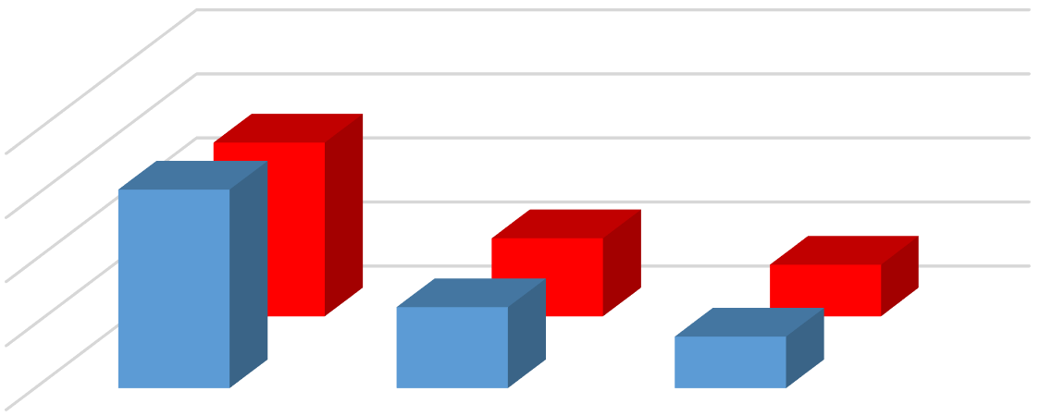

Revenue Low YoY (%)
Revenue High YoY (%)
0
50
100
150
200
2026
2027
2028
Year-over-Year (YoY) Growth Rates for Rental Revenue
Revenue Low YoY (%)
Revenue High YoY (%)

Sensitivity Analysis (Utilization Impact Rental Fleet)

Year | 100%  Utilization | 95%  Utilization | 90%  Utilization
2025 Low | $1,048,800 | $996,360 | $943,920
2025 High | $1,368,000 | $1,299,600 | $1,231,200
2026 Low | $2,907,000 | $2,761,650 | $2,616,300
2026 High | $3,755,520 | $3,567,744 | $3,379,968
2027 Low | $4,744,224 | $4,507,013 | $4,269,802
2027 High | $6,283,000 | $5,968,850 | $5,654,700
2028 Low | $6,653,774 | $6,321,085 | $5,988,397
2028 High | $8,968,320 | $8,519,904 | $8,071,488

Sales Division Projections – Chassis

(CAD, Low & High Scenarios)
Year | Low Projection | High Projection
2025 | $3,000,000 | $3,500,000
2026 | $5,000,000 | $6,500,000
2027 | $8,000,000 | $9,000,000
2028 | $11,000,000 | $12,500,000

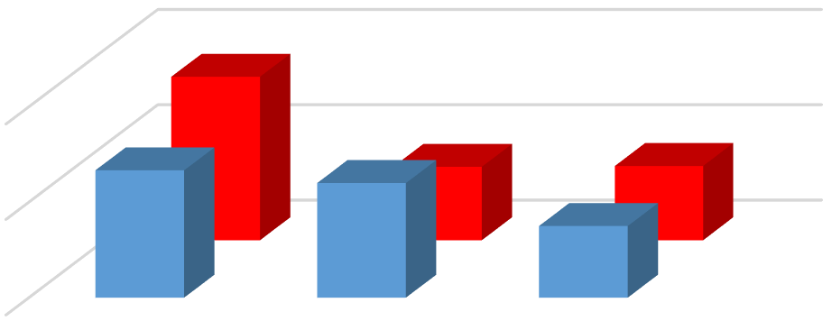

Low Projection YoY (%)
High Projection YoY (%)
0
50
100
2026
2027
2028
Year-over-Year (YoY) Growth Rates for Chassis Sales
Low Projection YoY (%)
High Projection YoY (%)

The Sales Division Projections for Chassis demonstrate a robust and optimistic outlook for Mainland Truck & Trailer Sales & Leasing, reflecting strong market demand and strategic growth opportunities from 2025 to 2028. With projected revenues rising from $3 million to $11 million in the low scenario and $3.5 million to $12.5 million in the high scenario, the chassis sales division is poised for significant expansion, achieving a compound annual growth rate of approximately 54–53%. This upward trajectory is fueled by the company’s competitive advantage in leveraging tariff-favored Canadian-manufactured chassis, enabling penetration into high-demand U.S. markets alongside established Canadian operations. The consistent year-over-year growth, particularly the substantial increases projected for 2026 and 2027, underscores Mainland’s ability to capitalize on rising freight volumes and port activity, positioning the chassis sales division as a cornerstone of the company’s diversified revenue strategy and a compelling opportunity for investors and lenders.
Sales Division Projections – Used Trucks & Trailers

(CAD, Low & High Scenarios)
Year | Low Projection  (10% CAGR) | High Projection  (15% CAGR)
2025 | $4,000,000 | $4,500,000
2026 | $4,400,000 | $5,175,000
2027 | $4,840,000 | $5,950,000
2028 | $5,325,000 | $6,850,000

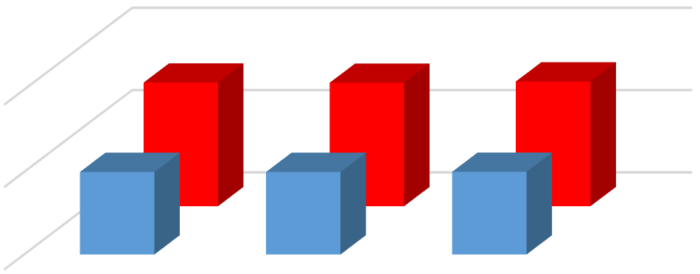

Low Projection YoY (%)
High Projection YoY (%)
0
10
20
2026
2027
2028
Year-over-Year (YoY) Growth Rates for Used Trucks &
Trailers Sales
Low Projection YoY (%)
High Projection YoY (%)
The Sales Division Projections for Used Trucks & Trailers showcase a steady and promising growth trajectory for Mainland Truck & Trailer Sales & Leasing, reinforcing the company’s diversified revenue model and its ability to generate consistent cash flows from 2025 to 2028. With revenues projected to grow from $4 million to $5.325 million in the low scenario (reflecting a reliable 10% compound annual growth rate) and from $4.5 million to $6.85 million in the high scenario (achieving an ambitious 15% CAGR), this division demonstrates resilience and market alignment. These projections capitalize on
Mainland’s strategic monetization of older fleet assets, complemented by strong demand in the North American used equipment market, driven by e-commerce growth and supply chain diversification. The predictable, incremental growth in both scenarios highlights the division’s role as a stable contributor to the company’s overall revenue, projected to reach $22.98 million to $28.74 million by 2028, offering lenders and investor’s confidence in Mainland’s balanced and sustainable expansion strategy.

Total Company Revenue Projections
(CAD, Low & High Scenarios)

Year | Rental Revenue Low | Rental Revenue High | Chassis Sales Low | Chassis Sales High | Used Truck & Trailer Sales Low | Used Truck & Trailer Sales High | Total Revenue Low | Total Revenue High
2025 | $1,048,800 | $1,368,000 | $3,000,000 | $3,500,000 | $4,000,000 | $4,500,000 | $8,048,800 | $9,368,000
2026 | $2,907,000 | $3,755,520 | $5,000,000 | $6,500,000 | $4,400,000 | $5,175,000 | $12,307,000 | $15,430,520
2027 | $4,744,224 | $6,283,000 | $8,000,000 | $9,000,000 | $4,840,000 | $5,951,250 | $17,584,224 | $21,234,250
2028 | $6,653,774 | $8,968,320 | $11,000,000 | $12,500,000 | $5,324,000 | $6,843,937.50 | $22,977,774 | $28,312,257.50

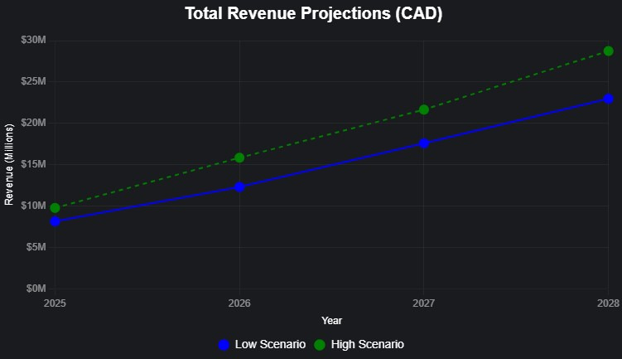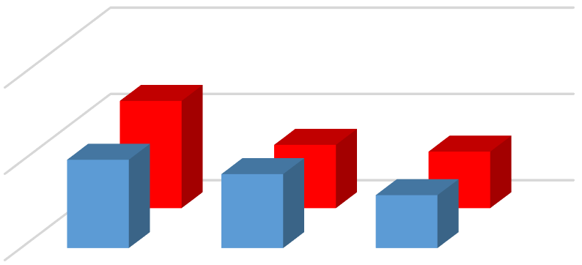

Total Revenue Low YoY (%)
Total Revenue High YoY (%)
0
50
100
2026
2027
2028
Year-over-Year (YoY) Growth Rates for Total Company
Revenue
Total Revenue Low YoY (%)
Total Revenue High YoY (%)

Closing Summary & Lending Proposition

Mainland Truck & Trailer Sales & Leasing offers a secure, asset-backed lending opportunity that combines predictable recurring income, diversified revenue streams, and tangible collateral in the form of a modern, fully utilized fleet. Our business model has been tested and proven, generating stable monthly cash flows from long-term rental contracts with a 90% utilization rate across all units. This high utilization provides lenders with visibility into consistent repayment capacity, supported by contractual revenues and assets that maintain strong resale value. The company’s expansion strategy—adding 150 to 200 units annually between 2026 and 2028—is deliberately measured, ensuring that each asset is deployed immediately into revenue-generating service, minimizing idle time and maximizing return on capital. All fleet additions follow a disciplined allocation plan based on confirmed customer demand, market analysis, and geographic positioning to capture high-volume freight flows in both Canadian and U.S. markets.
Our competitive advantage is further strengthened by the use of Canadian-built chassis, which benefit from favorable tariff treatment when sold or rented into the United States. This allows us to price competitively against U.S.-based suppliers, win market share, and maintain strong margins without compromising quality. Unlike many industry players with limited operational flexibility, our cross-border presence—strategically located in British Columbia, Alberta, Ontario, and Washington State—enables us to serve both domestic and international freight operators efficiently. This reach, combined with modern fleet technology such as GPS tracking and robust in-house and partner maintenance capabilities, ensures high uptime, reduced operating risk, and long-term asset value retention.
Financially, the company is on a clear growth trajectory. Total revenue is projected to increase from $8.14 million–$9.77 million in 2025 to $22.98 million–$28.74 million in 2028, representing a compound annual growth rate of 41–43%. These projections are not speculative—they are grounded in verified market demand, existing contractual relationships, and industry trends such as e-commerce expansion, port throughput growth, and supply chain diversification. The revenue mix, consisting of recurring rental income, high-margin new chassis sales, and monetization of used trucks and trailers, reduces exposure to any single market segment and provides multiple levers for maintaining profitability under varying economic conditions.
From a lender’s perspective, Mainland Truck & Trailer Sales & Leasing represents a well-capitalized, professionally managed, and operationally disciplined borrower. The company’s debt servicing ability is supported by a diversified and contractually secure income base, with all financed assets providing direct collateral coverage. Our management team, with decades of experience in transportation asset management, has demonstrated the ability to execute strategic growth without overextending operational capacity. This track record, combined with conservative financial planning and asset-backed lending structures, ensures that obligations can be met in full and on time. For financial institutions seeking to deploy capital into a low-risk, high-visibility opportunity with both stable returns and significant upside potential, Mainland offers a compelling, well-supported case for partnership.

